**Project description**

A large part of working with data is being able to interpret data visualizations and explain your insights to others. To give you some practice with this, we’ve selected a few Tableau dashboards for you to explore, links are below. Choose one of these dashboards, whichever one interests you the most, and find **three insights** in the visualizations. For each insight, **provide a static image** that shares what you found. Write a short report explaining each observation and how you found the information to reach your conclusion from the dashboard. Altogether (including images), your report should be 1-2 pages.

**Project Rubric**

Rubric Link for this project: [**https://review.udacity.com/#!/rubrics/1063/view**](https://review.udacity.com/#!/rubrics/1063/view)

**Screen Capture**

If you have not done a screen capture before, here are the instructions for a [**Mac**](https://support.apple.com/en-us/HT201361) or [**PC**](https://www.youtube.com/watch?v=_qcFOoNR9vI). You can then copy and paste the image into your report.

**Example**

For example one insight might look like:

**[[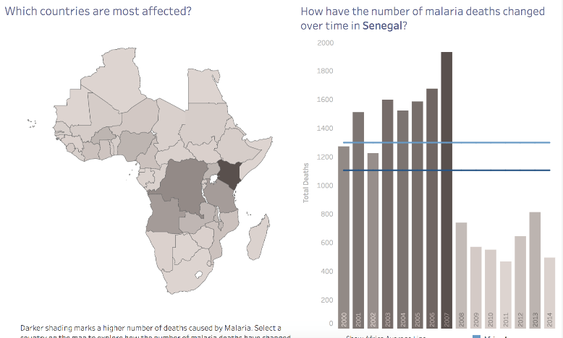](https://classroom.udacity.com/nanodegrees/nd100/parts/d5743fb7-80b8-41da-94f5-fd17f5c1f8f8/modules/186d1771-3d72-4493-800f-12b4416e8587/lessons/07b383df-b9dd-4e67-9baa-cbe1a4107bbf/concepts/cfe8c3aa-b5c3-4d99-bbbc-4a8c751debf3)](https://classroom.udacity.com/nanodegrees/nd100/parts/d5743fb7-80b8-41da-94f5-fd17f5c1f8f8/modules/186d1771-3d72-4493-800f-12b4416e8587/lessons/07b383df-b9dd-4e67-9baa-cbe1a4107bbf/concepts/cfe8c3aa-b5c3-4d99-bbbc-4a8c751debf3)**

“Deaths per year due to malaria in Senegal have been halved since 2007. From that dashboard, I clicked on Senegal on the map, this showed deaths due to malaria for each year from 2000 to 2014. Before 2007, there were about 1400-1500 deaths per year. After 2007, starting in 2008, deaths were reduced to about 600-700 per year.”

Submit this report as a PDF. All the images and your summary should be in **one** PDF with each summary following the image of the insight.

**Choose from these dashboards**

[**Madrid in Detail**](https://public.tableau.com/en-us/s/gallery/madrid-details?gallery=featured)

[**Malaria in Africa**](https://public.tableau.com/en-us/s/gallery/malaria-africa?gallery=featured)

[**LinkedIn Top Skills**](https://public.tableau.com/profile/matt.chambers#!/vizhome/LinkedInTopSkills2016-MakeoverMonday/LinkedInTopSkills2016-MakeoverMonday)

If you choose to work with the LinkedIn data, you may find [**this article**](https://blog.linkedin.com/2016/10/20/top-skills-2016-week-of-learning-linkedin) helpful for the insights that you draw.

**Common Questions and Answers:**

[**https://knowledge.udacity.com/?nanodegree=5ce69a5c-496f-11e8-b509-932e3a4da789&page=1&project=5545f27a-496f-11e8-b325-17349c4fea86**](https://knowledge.udacity.com/?nanodegree=5ce69a5c-496f-11e8-b509-932e3a4da789&page=1&project=5545f27a-496f-11e8-b325-17349c4fea86)